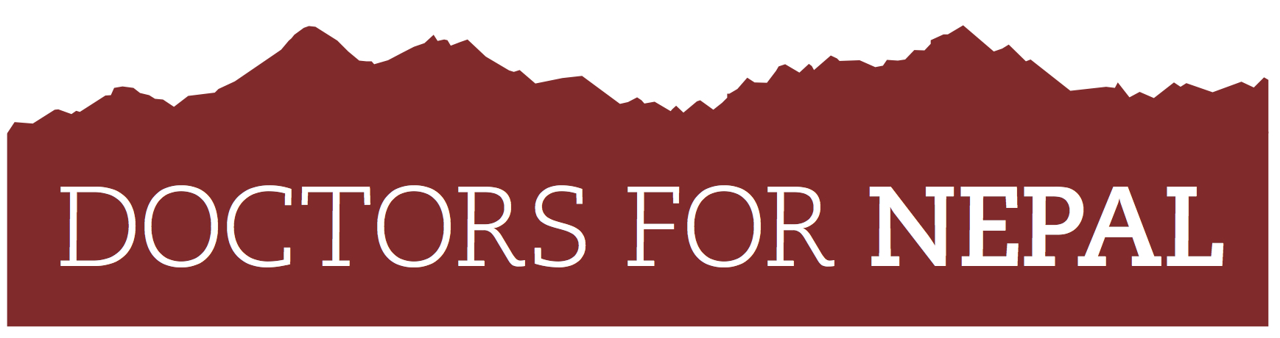

www.doctorsfornepal.org
info@doctorsfornepal.org
+44(0)7768 980960

UK registered charity no: 1133441
________________________________________________________________________________________________

ELECTIVE PACKAGE
DOCTORS FOR NEPAL is a UK registered charity that aims to improve healthcare in rural Nepal. The charity provides scholarships to students from impoverished backgrounds from remote areas of Nepal. They are carefully selected and then attend medical school or nursing colleges in Nepal. Once graduated, these students return to their communities to serve as doctors and nurses providing much needed medical care to tens of thousands of patients for a commitment of at least four years. We at DFN are keen that UK medical students can benefit from the unique experience of working in a resource poor setting in one of the world’s most beautiful countries. The challenges of an elective in Nepal are not to be understated, but with an open mind, and a sense of adventure, we know that the previous students have had extraordinary experiences which will serve them well in their future careers, wherever these may be.
HOW DFN CAN HELP WITH ELECTIVES:
- We can help facilitate urban electives for UK medical students to Kathmandu, Nepal.
- We have an electives agreement with Patan Academy of Health Sciences (PAHS) in Kathmandu (where our Nepalese medical students study).
- Once the PAHS electives application is complete, it must be returned to us (DFN) who will send it to PAHS for their processing and agreement.
- The usual fee for electives at PAHS is USD400 for 4 weeks (100USD/week), however, should your elective need to be 6-8 weeks you will not be charged a higher fee.
- If you apply to do your elective through us, the fee will be wavered by PAHS and donated directly to DFN (you will need to arrange a donation to DFN prior to departure)
- Lodging/food can be arranged through PAHS, or independently.
- The only place where you can do your elective with DFN is at PAHS (minimum 2 weeks per department). You will shadow a senior Nepalese doctor and will NOT be expected to carry out any medical procedures independently.
- Should you wish to have a rural placement, you will have to enquire directly through PAHS once selected for an urban placement. We would highly recommend some urban experience to get yourself acclimatised to Nepal’s culture. We are unfortunately not able to directly help you to secure a rural placement however are able to offer advice and contacts.
- Gaining a rural placement will depend on whether PAHS have any of their own students on placements in rural areas at the time of your desired elective, and whether transportation is feasible (June-early September is monsoon season, and transport can be dangerous).
- DFN cannot cover any medical insurance. You will need to organise your own medical insurance.
- DFN cannot directly assist with transport. All flights to and transport in Nepal will be at your own cost and risk. However guidance can be given for in-country transportation options.
- Please be realistic with your expectations and planning. There are significant risks with the terrain (poor roads, landslides, overloaded buses etc.) as well as under-maintained planes. You need to consider which season you intend to go, and bare in mind that the majority of medical care in Nepal is extremely basic. For this reason you must ensure that your insurance includes helicopter assistance, plus repatriation to your home country.

WHAT DOES PATAN ACADEMY EXPECT FROM ITS ELECTIVES?
- Electives work 5 days a week (8.00am - 4.00pm, closed Saturday and Wednesday). You must agree to comply with the department and hospital rules and regulations. You will be unable to take a holiday during your elective posting.
- PAHS require a letter of recommendation from your University/Hospital in support of your elective.
- Electives consist of observation only (i.e. shadowing senior doctors). However, you will have the opportunity to attend the weekly department conferences and rounds that are held every Friday morning, and also have access to the library, which includes internet connection.
- All Visa and travel arrangements must be organised by you.
- The hospital does not provide any insurance benefits (medical or otherwise)
- During your time in the hospital a white coat must be worn at all times, so please bring one with you. If you don't have one it can be arranged at the hospital.
- Unfortunately, you are not able to take advantage of the accommodation block at the hospital, but PAHS would be happy to give you contact addresses of people who can arrange accommodation for you. You will need to let PAHS know 1 month prior to your arrival should you need this help.

HOW TO APPLY:
- Please fill out and send back the attached PAHS application form to DFN.
- Obtain a letter of recommendation/support from your University/hospital.
- Please send a covering letter, application form and your letter of recommendation to cesca@doctorsfornepal.org. Cesca is DFN’s UK manager.
- Dr Kate Yarrow, founder of DFN, will assess your application and, if suitable, we will send on with our own letter of recommendation, for PAHS to make their selection.
- If selected, you agree to donate the sterling equivalent of USD400 to Doctors for Nepal as payment for your fees at PAHS. (They have very generously agreed to waive DFN electives fees.) Details of how to donate will follow once you’ve been selected.
- DFN will inform you if you have been successful in your application.

Should you have any further questions please don’t hesitate to contact Cesca Eaton at cesca@doctorsfornepal.org or 07768 980960

Good luck and Namaste!

