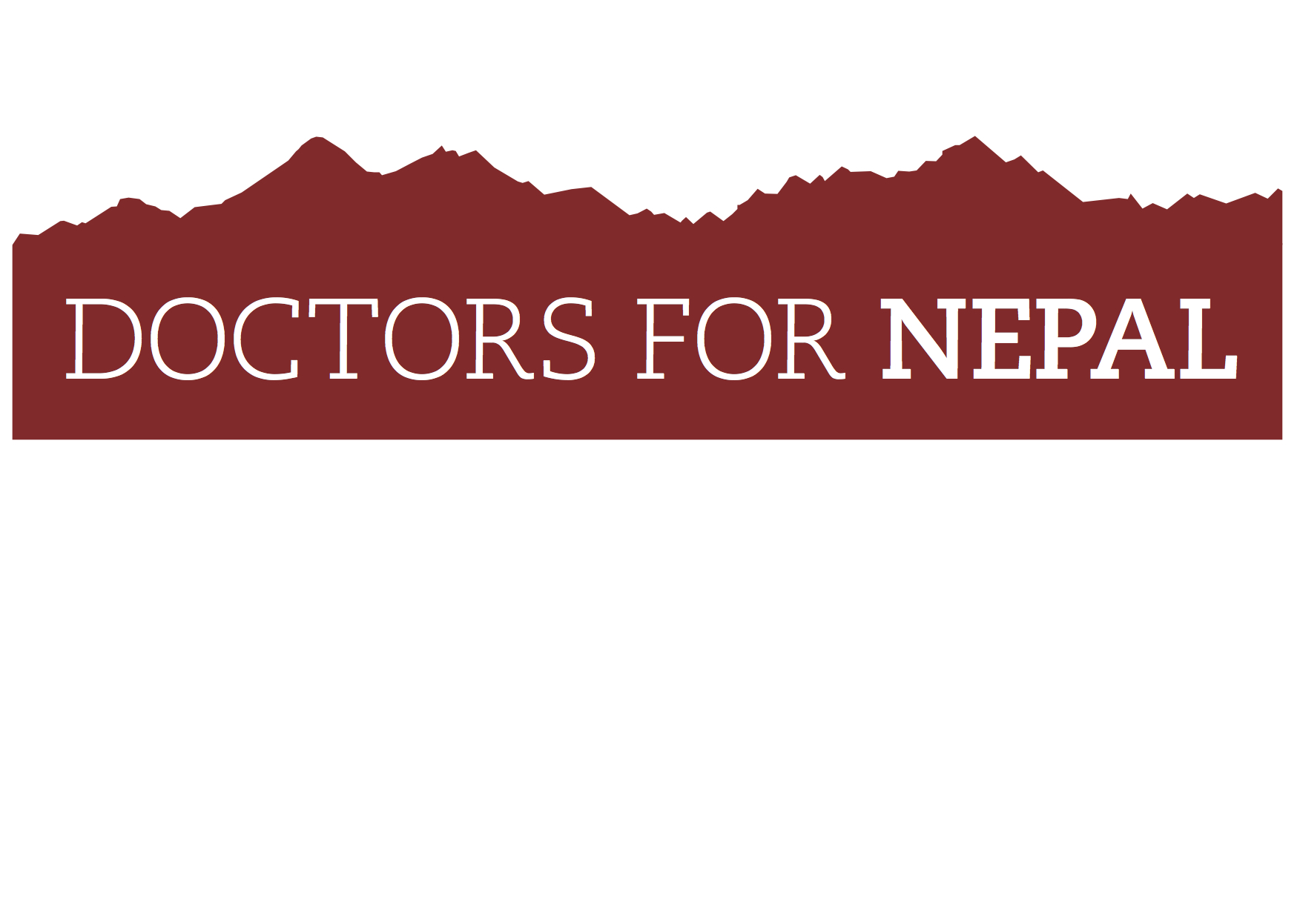
Highwell, The Drove, Hamsey, Sussex BN8 5TD
www.doctorsfornepal.org
cesca@doctorsfornepal.org
+44(0)7768 980960

UK registered charity no: 1133441
________________________________________________________________________________________________

DOCTORS FOR NEPAL CHARITY BIKE RIDE
Saturday 27th – Sunday 28th June 2019
This summer Doctors for Nepal is organising a charity bike ride with the challenge to climb the equivalent height of Mount Everest from base camp on a bike – circa 3,400m. The ride will be the perfect way of raising much-needed funds to help improve healthcare in rural Nepal, but also having a lot of fun.

When: 29th – 30th June 2019 (arriving Friday evening 28th June)
Where: The Yorkshire Dales National Park - base camp will be 5 miles from Hawes
Route: The route will be two big loops setting out each morning from Hawes. The rides have been chosen for road quality, scenic beauty, rideability and simplicity of directions. This is not an easy ride – the North Face ride is 95km with an ascent of 1,710m, and the South Face ride is 125km with an ascent of 1,660m. It’s recommended for experienced cyclists and may require some training. It is challenging in places with steep ramps and the amount of climbing involved means that the cycling will be long, hard and will require stamina. Link to maps: https://www.bikemap.net/en/c/266753/
Cyclists: Experienced cyclists, 15 max (if successful the event will grow to approx 100 in 2020)

What you get ON THE WEEKEND:
- Free DFN cycling shirt to wear on the ride
- Free event pack with full details and maps with route outlined
- Briefing at base camp in Hawes on Friday night, with meal provided
- Sunday evening BBQ at base camp
- Packed lunch en route on both cycle days
- Checkpoints along the route with drinks, snacks/energy bars, big smiles and encouragement
- Basic first aid in support vehicle
- N.B. Insurance is not included
- You will need to arrange your own accommodation (suggestions will be given)

What you need to do NOW:
- Pay the entry fee of £120 (non refundable)
- Fill in the registration form and return (see below)
- Get your friends to sign up too!
- Get your friends, family, colleagues to sponsor you via our DFN dedicated Charity Cycle Ride page: https://www.justgiving.com/campaign/DFNbikeride2019
- Spread the word via Facebook, Twitter, Instagram etc
- We are aiming high and hope to raise circa £15,000 in donations

How to register:
Email cesca@doctorsfornepal.org and she will send you a registration form which you should fill in with all your details, pay the appropriate fee, tell us what size cycling shirt you need and send registration form back to cesca@doctorsfornepal.org or if enclosing a cheque, post to Cesca Eaton, DFN, Flat 1, 87 Enys Road, Eastbourne, East Sussex BN21 2DX

How to pay:

Pay online via BACS: please give a reference of BIKERIDE
Account name: Doctors for Nepal
Account number: 00284204
Sort code: 30-91-25
OR
Pay by cheque, made out to Doctors for Nepal, giving reference of BIKERIDE, and send to
Cesca Eaton, Flat 1, 87 Enys Road, Eastbourne, East Sussex BN21 2DX

Fundraising:

DFN CHARITY BIKERIDE is one of DFN’s major fundraising events for 2019 to help provide much needed medical care in rural Nepal. We therefore ask that every single rider in TEAM DFN aims to raise £1,000 in sponsorship to meet our target. We have made it easy for everyone to do this by setting up a dedicated JustGiving page: https://www.justgiving.com/campaign/DFNbikeride2019

So please send all your sponsors to this link where they’ll be able to give directly to Doctors for Nepal. Don’t forget to suggest that if they are UK taxpayers they should tick the Gift Aid box so that we can reclaim Gift Aid on every donation made. Spread the word via social media - put info up about what you’re doing and how to donate via the JustGiving link, on Twitter, Facebook and Instagram, and watch the DFN Charity Bike Ride total rise to new heights thanks to YOUR fundraising efforts.

We’ll be tweeting and posting on social media and on our website too. Couldn’t be simpler!

If you require any more information, simply get in touch and we’d be happy to help in any way we can.
Contact Cesca on 07768 980960 or cesca@doctorsfornepal.org

About Doctors for Nepal:
Doctors for Nepal is a UK registered charity that aims to improve healthcare in rural Nepal by providing scholarships to under-privileged medical and nursing students. They then return to their remote communities to provide desperately needed medical care.

If you are ill and live in the remotest parts of Nepal, high up in the mountain villages of the Himalayas, it can take up to 9 days of hard walking to reach a health-post where, if you’re lucky, you might find a doctor who can treat you. Then you have to walk all the way home again.

www.doctorsfornepal.org

